Ronell Adri Week 11 Work Log
Before:
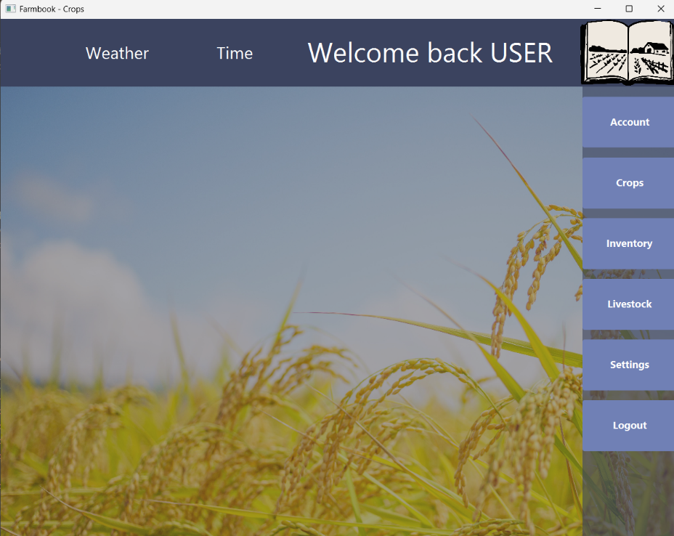

After:
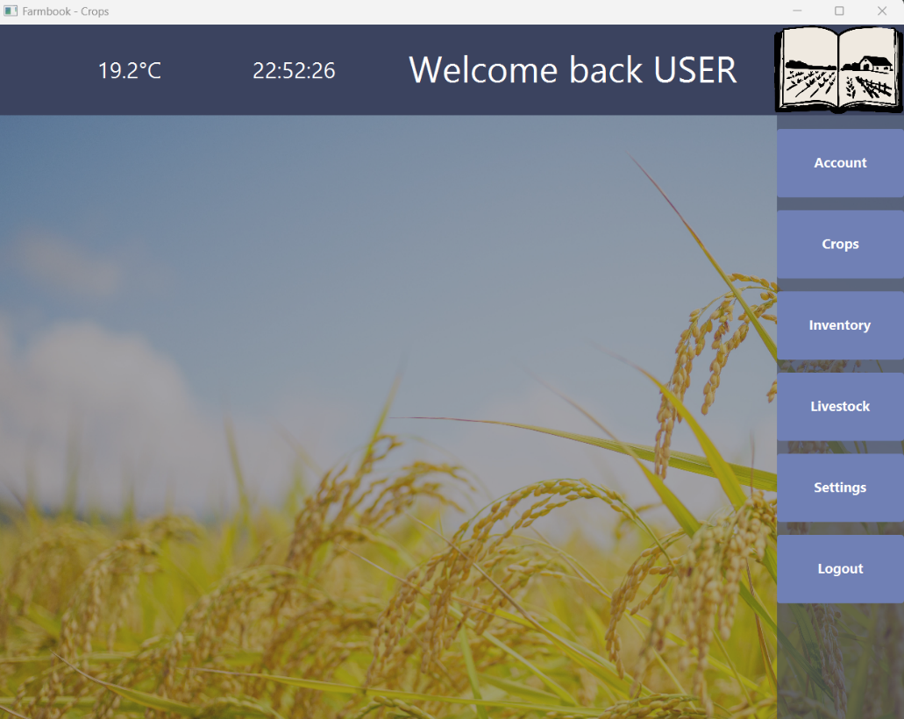

The figure below shows the following samples that led to the development of the feature:
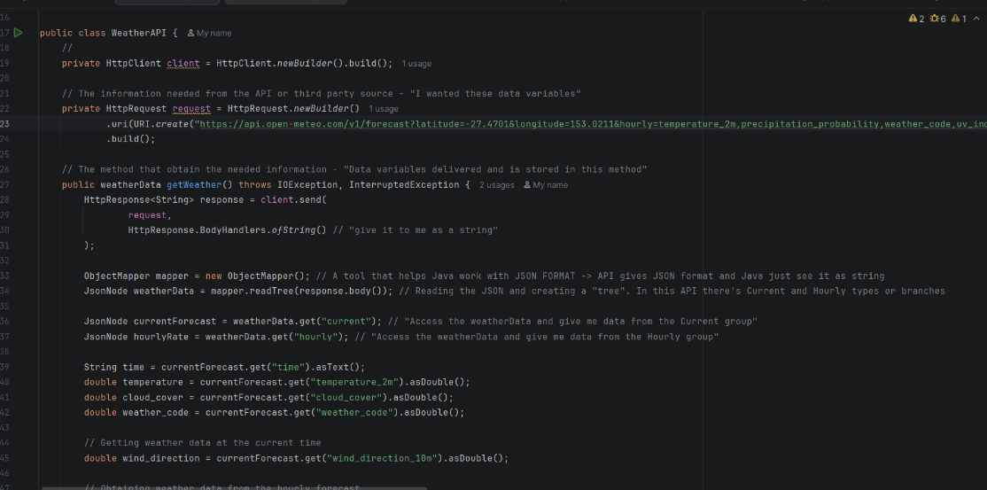
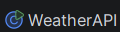

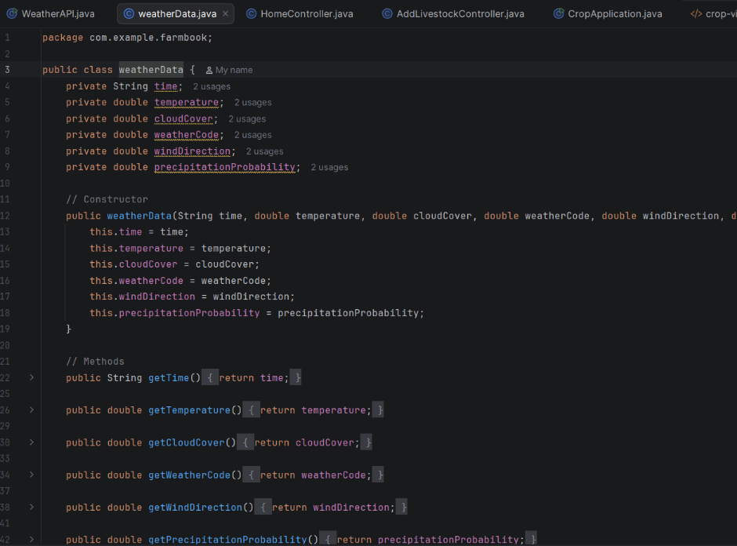

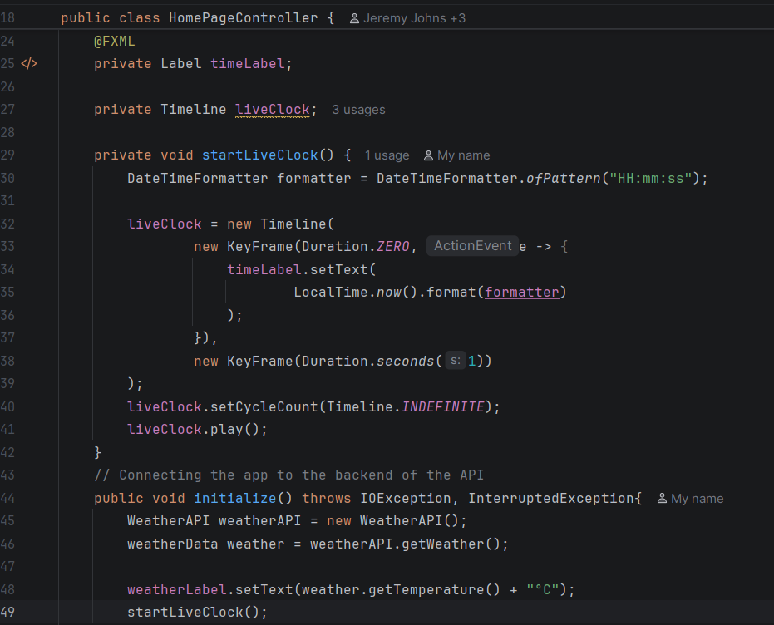

For this period, my job is to ensure that our app displays basic weather conditions and statistics that can aid our target users that suits the purpose of our app. To achieve that goal, I have to obtain a free weather API that will provide the necessary data, and it is my job to link our app to that API. Additionally, I’ll also be working on additional features like implementing a live time into the app as seen in the figures shown in this document.
The API utilise in this project is Open-Meteo and the link is shown below:
🌤️ Free Open-Source Weather API | Open-Meteo.com
While going through this API, I have realised that it has contain several variables that can significantly aid farmers via crucial current weather statistics like soil temperature, evapotranspiration etc. So a portion of the time went on researching on what weather variables that we can utilise into our app and developing a stage plan of the development of this segment of the application. The figure is shown below and is the first draft with no yet consultation with the team members.
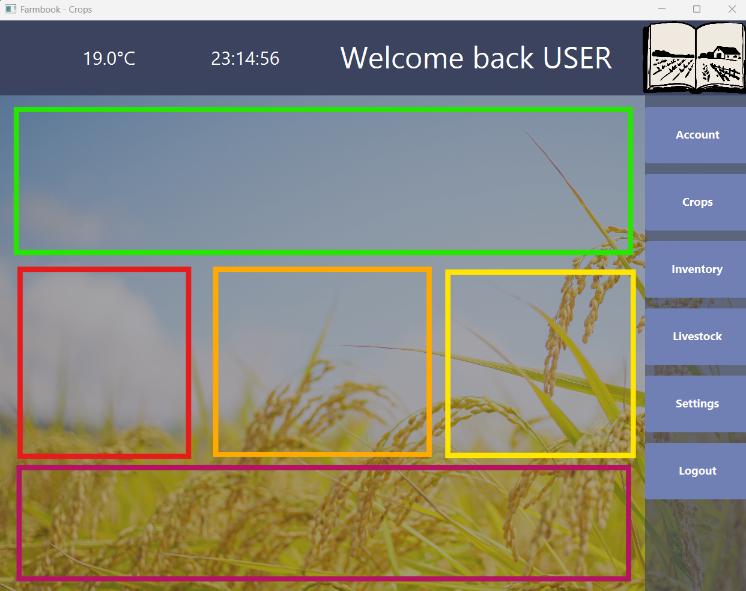
The orange box will display the current weather condition using an icon. This provider farmers with a simple visual representation of the weather they can expect on their land.
The green box will display important agricultural weather statistics, such as Vapour Pressure Deficit (VPD) and surface pressure. These statistics will help farming operations, including crop management and livestock care.
Red box will display the current temperature in a clear and accessible format. The existing temperature display will be redesigned to fit within this designated area.
The yellow box will display the current time. The existing time display will be moved into this designated area.
The purple box contains supplementary information that is not essential for everyday use but may be useful on occasion. These sections will display details about when the weather data was recorded, allowing farmers to understand how recent the information is.

